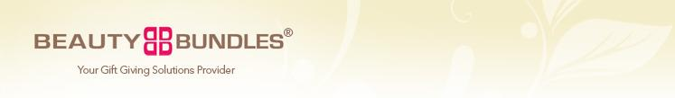
Beauty Bundles eNewsletter: Issue #1  Newsletter/Sale Announcement Title Here  Placeholder introductory text. Beauty Bundles believes that beauty enriches our lives and the lives of those around us. Our passion at Beauty Bundles lies in finding beautiful things and sharing them with our friends. The make up of the Beauty Bundles team is a combined 30 year history in the spa and beauty industry. These experiences have shown that the most important quality a person can have is to feel good about themselves. | 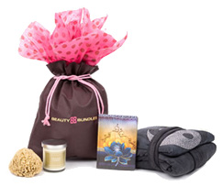
Our Products  Our selection of bundles offers something for all occasions...  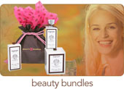 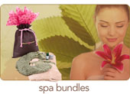  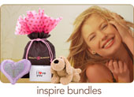 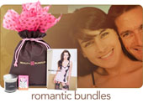 | What’s a Beauty Bundle?  CATERING TO GIFT GIVING NEEDS  We have carefully bundled unique fashion and beauty items that compliment and complete your gift giving needs. All bundles include a recyclable, re-usable, non-woven Beauty Bundle bag.  Feed Good.  OUR PHILOSOPHY  We believe that beauty enriches our lives and the lives of those around us. Our passion lies in finding beautiful things and sharing them with our friends.

Copyright 2009 Beauty Bundles®

